1. **IOT Based Smart Home Using Cisco Packet Tracer**

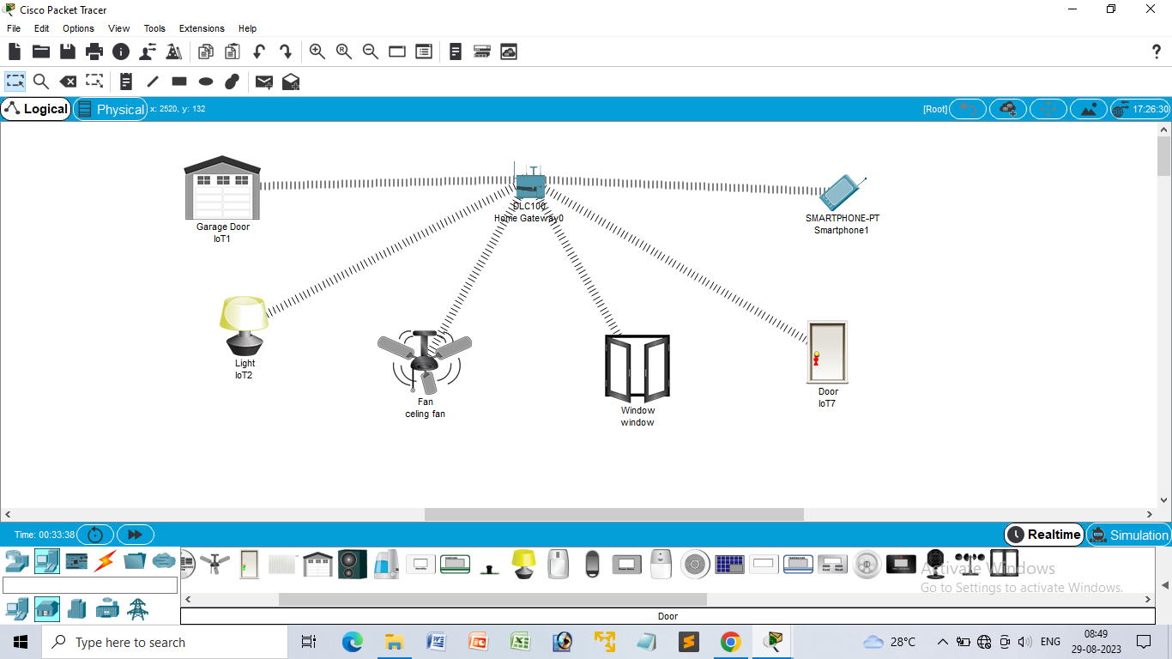

1. **Smart Garden in Cisco Packet Tracer**

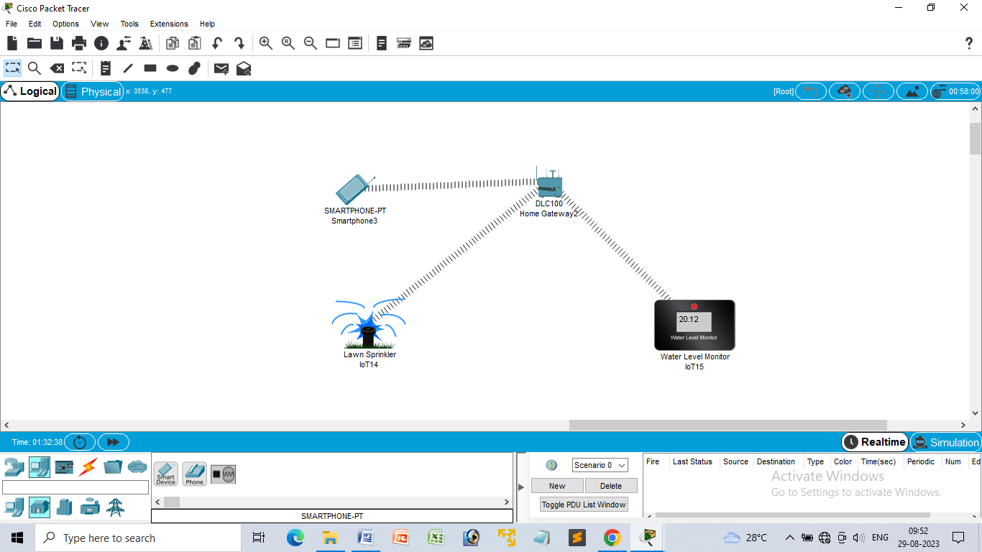

1. **IOT Devices in Networking Using Cisco Packet Tracer**

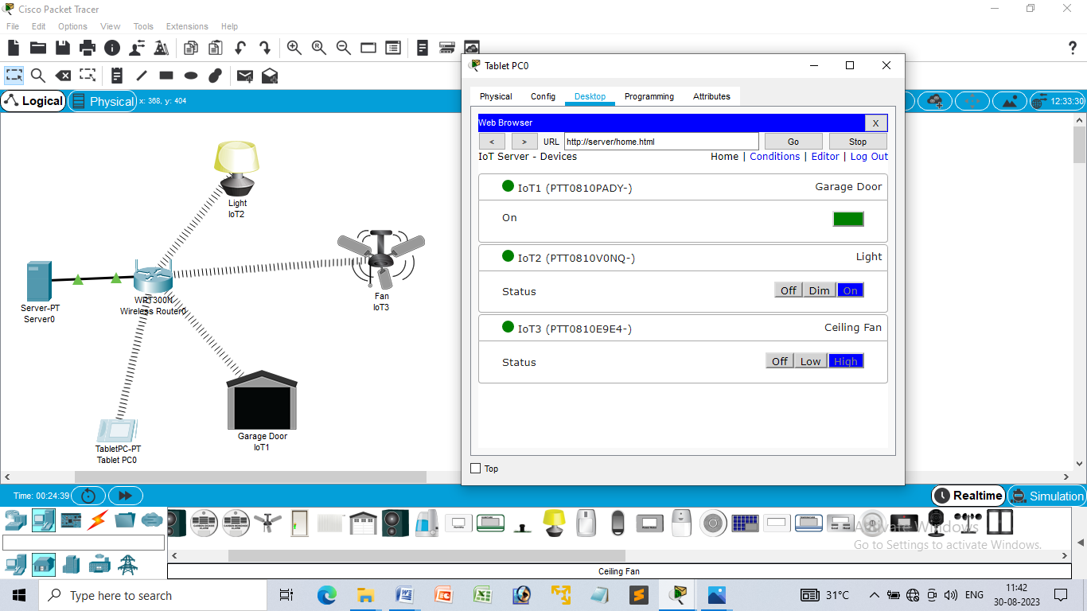

1. **Simulating X,Y,Z Company Network Design**

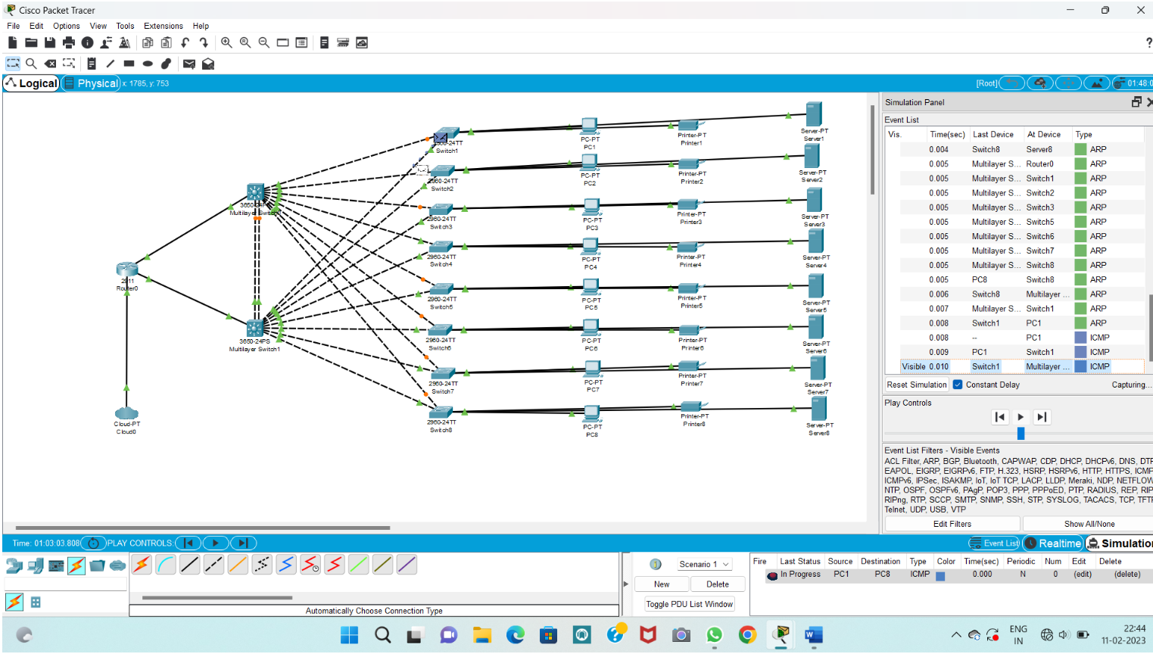

1. **Make Computer Lab in Cisco Packet Tracer**

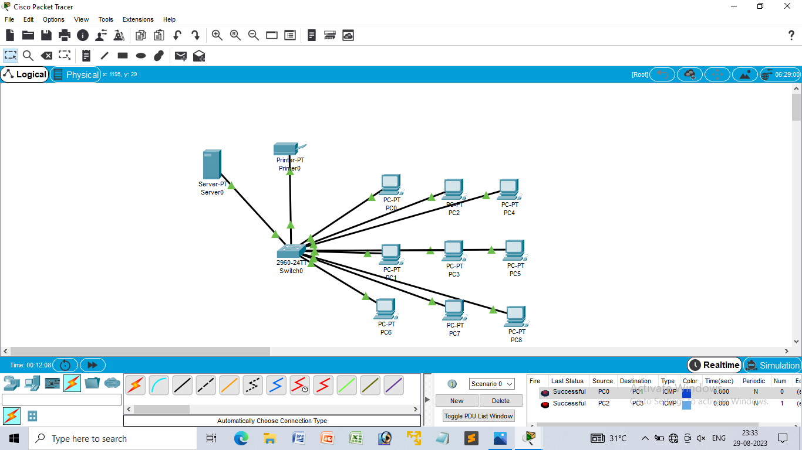

1. **Simulate a Multimedia Network**

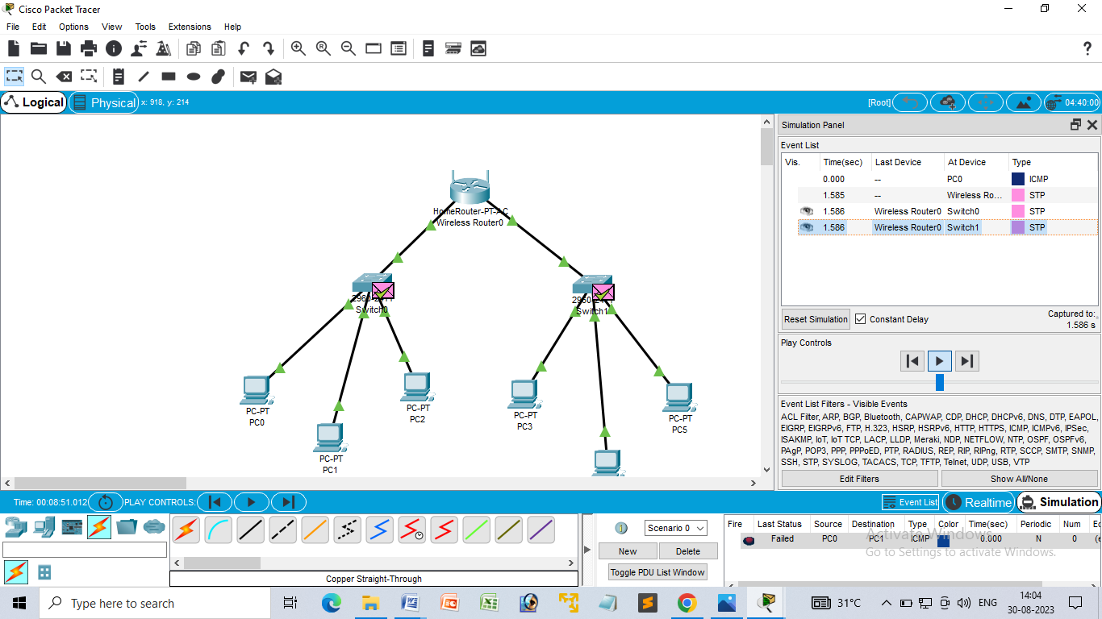

1. **AAA Local & Server Based Authentication Configuration in Cisco Packet Tracer**

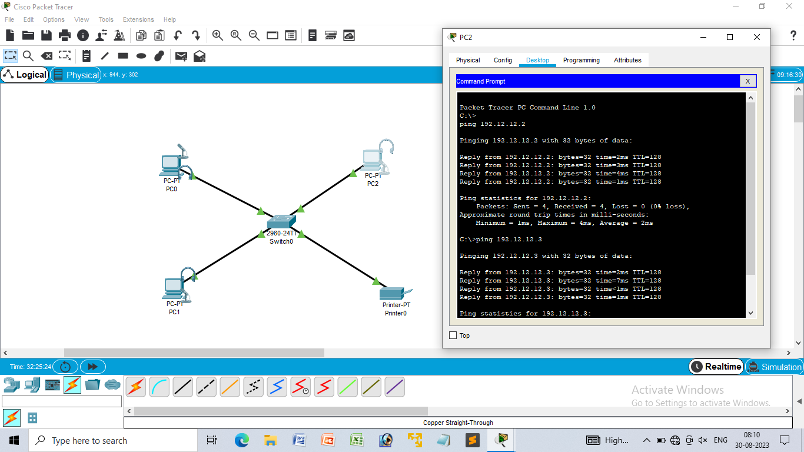

18. **IOT Based Smart Home using WPA Security & Radius Server**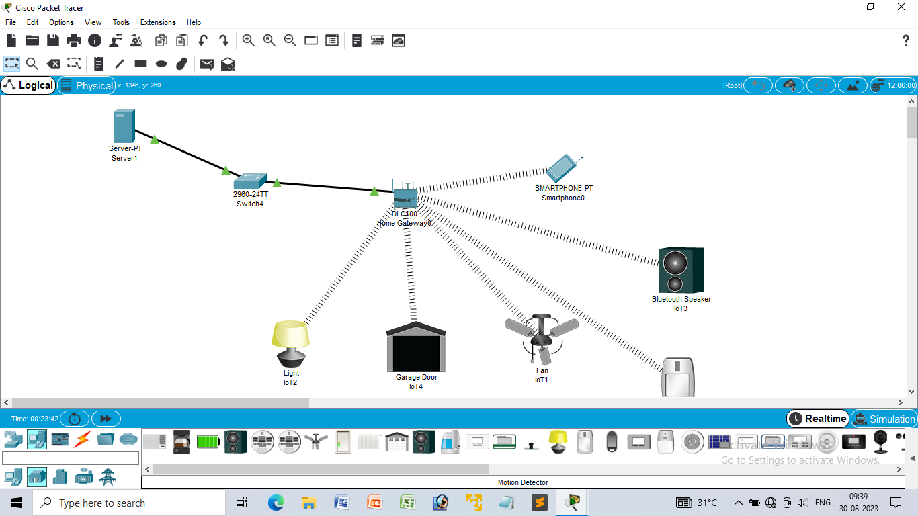

1. **WLAN Using Cisco Packet Tracer**

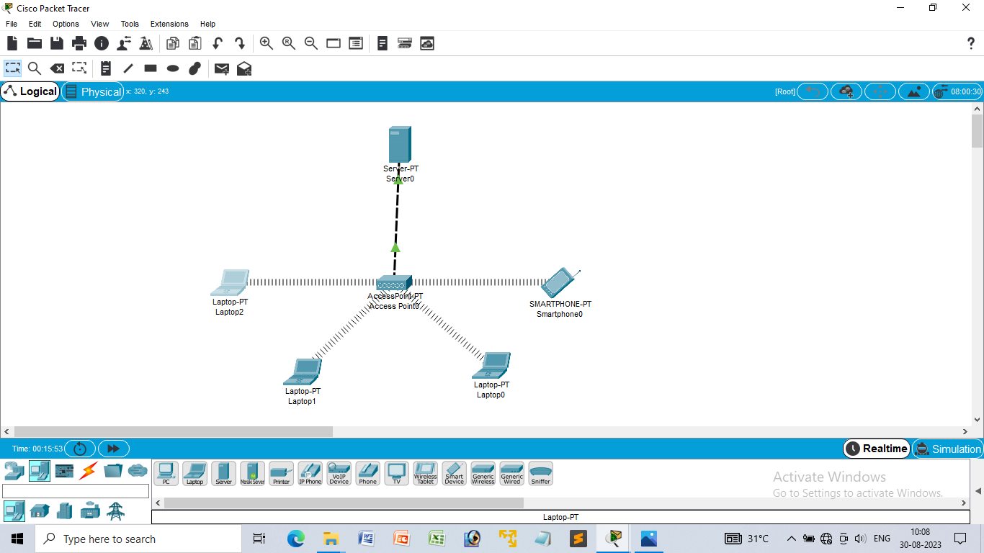

1. **Control of Fan, Light, Window & Application of Using Cisco Packet Tracer**

